
Fox Hollow
MISSION STATEMENT
The Fox Hollow PTO exists to build strong relationships between parents, teachers and students, to provide essential funding to help enrich all students’ academic experience, while creating a strong school community through social events and activities.

PTO Meeting
September 5, 2025
8:15 AM

PTO Board Attendance
Voting Members

⃞x Sara Olmsted President (only votes in the event of a tie)
⃞x Shannon Hachmeister Secretary
⃞ xMike Page Treasurer
⃞x Joanna Farnsworth Co-VP Social Events
⃞⃞⃞ Candace Tompkins Co-VP Social Events
⃞⃞ xKerry Vasboe-Peach VP Community and Wellness
⃞ Davy Strategier VP Hospitality
⃞x Molly Thompson VP Fundraising
Attendees

⃞ xAshley Gray Principal (non-voting member)
⃞x Angel St. Pierre Office Manager
⃞ Committee Chairs

Org Chart/Open Board Positions

Board Members and Chairs
- OPEN POSITIONS: Shannon will start advertising in the newsletter
  - Fund$ for Excellence Chairs -Potential Co-chair, Molly reaching out
  - Student Directory Chair
  - Donuts with Dear Ones Co-Chair
  - School Toolbox Chair
  - Spirit Night & Loyalty Chair

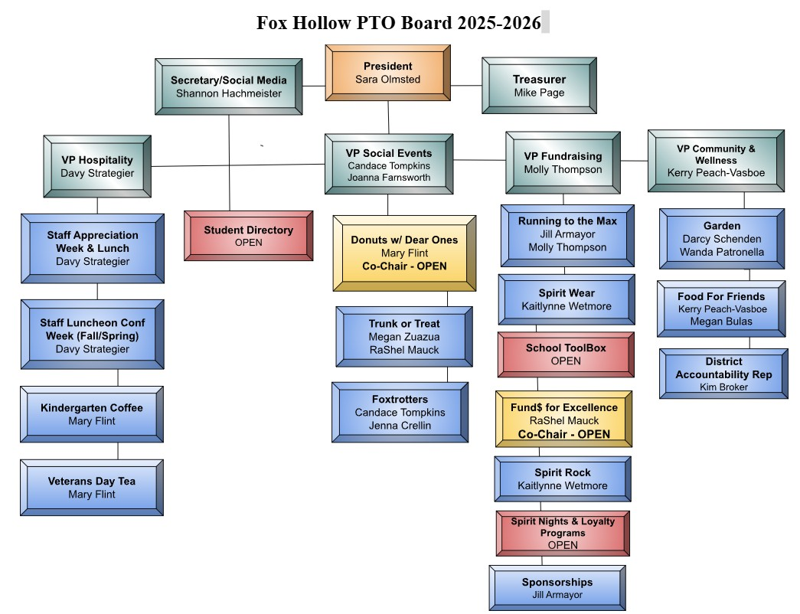

Volunteer List
- Please utilize these volunteers as much as possible
- Hope is that these volunteers will become part of the Board and takeover the various chair positions as they open up
- List found here: https://docs.google.com/spreadsheets/d/1NpWX445eQYwLmUeeCqPdfNSHheymWU3h/edit?usp=drive_link&ouid=107550947223271717452&rtpof=true&sd=true

President

- President’s Update:
  - PTO board meetings also being PTO General meetings – follow same format as Liberty Middle School
    - Start October
  - 9/10 – first Parent Council Meeting
  - Any open PTO positions – interest?
- General PTO meeting will be open at our current meetings 4x/year for the general public instead of evenings – October, November, February, April

Secretary

- HOA Newsletter
  - Add in general meeting to HOA for October
- Newsletter
- Website – add RTTM info to website

Treasurer

- 25/26 SY Budget approved at room parent meeting
  - New district requirement for assault - questionnaire
  - Now using PTO today instead of Quickbooks
    - Helps keep us in compliance
  - District moving from RevTrack to My School Box

Hospitality

- ?

Social Events

- Donuts with Dear Ones recap
  - 50 dozen, only 2 dozen left
  - Moving to 3 tables
  - Need more volunteers
  - Music
  - More places to have signs to donate
- Trunk or Treat
  - Need volunteers from board members for Cash box
  - No sponsor trunks
  - Security will head the line

Fundraising

RTTM Updates
- Card My Yard: donating a sign for the run.
- DJ: Kindergarten Family owns a DJ company
- i9 Sports (Nate Sutton): will set up a tent at the run. He is talking to his boss to
provide one free season, sport of choice, for each grade to award to one student for
sportsmanship.
- MC Update: Ms. McKenna mentioned she may be out of town; need to confirm and line up an alternate MC if necessary.
- Finish Line: Shannon Pray will again help with finish line decorations/beautification.
  - We will need to find a person to take this over next year. It would be great to find someone who can help this year and take it over next year.
- Prizes: Currently working on securing prizes and finalizing with Ashley. Local Business prizes: Target, Boondocks, i9, Urban Air, Lava Island, Denver Museum of Nature and Science
- Marketing Materials: Save the date went out in newsletter and is on marquee. Flyer with schedule for Newsletter this week.
- Will send flyers and Lap Cards to printer on Monday, 9/8.
- Registration and Volunteers: Plegestar and Sign Up Genius in progress.

- RTTM

  - Packets will go out 11th
  - Fundraising begins on the 12th
  - Last day for donations is the 9/30
  - Ashleys challenge 13-14
  - Jarons challenge 20-21
  - Prizes
    - Big prize is nuggets game on november 7

Sponsorships Updates from Jill
- Year Long Sponsors:
  - David & Jill Armayor Real Estate- we have a new logo!
  - Wolf Law
  - Kumon
  - Lubos
  - Barry’s
- 1st Quarter Sponsors:
  - Z Ultimate
  - Michael Scott Drum Lessons
  - Card My Yard
  - Children’s Art Classes
- 2nd Quarter Sponsors:
  - Z Ultimate
- Website needs to be updated with all sponsors here:
https://www.foxhollowpto.org/sponsors
- All logos for this school year can be found here:
https://drive.google.com/drive/folders/1U_i5gD7VeIOXh4SKGgIKmG3KTOQpC
CRw

- Still looking for more sponsors... I am hoping to get one or two more year-long sponsors. If I can’t secure them in the next week, I am going to move forward on ordering the banner, so that it can be ready for the run.

Spirit Wear
- I will check in with Kaitlynne on updates – order forms went home yesterday
- Would like spirit rock to be promoted

Spirit Nights
- Urban Air: September 5th (flyers went home in folders); 20% back-to-school event.
- Chick-fil-A: October 9th, 5–8 PM (Parker/Chambers).
- Howdy’s Ice Cream: February 5th, 3–8 PM.
- Fuzzy’s Tacos: April 3rd, 4–8 PM. * Need to confirm
- Skate City (Aurora): May 14th, 6–8 PM.
Potential Spirit Nights
- Dion’s Pizza: Not available November 18th. Open spring dates: March 17, 18, 24, 25,
- 31; April 1, 14, 15, 21, 22, 28, 29.
  - Target to change to March
- On the PTO website they have the date as November 18th which is not available,
- need to remove.
- IHOP: Available Mondays–Wednesdays, 4–8 PM. They donate 20% of sales. Require 2 weeks of advertising, possibly a poster for school doors.

New Opportunity
- Children’s Art Classes (Theresa Letman): Offering a Parent’s Night Out fundraiser.
Kids do an art project while parents get a night out. School receives a percentage of
proceeds. Theresa will provide more details soon.

Community & Wellness

- Garden projects
- Food for Friends
  - 6-10th of October
  - Curbside pick up
- Need to remove the hay bails from the garden-collecting mice
Principal Update:
- Capturing kids hearts-this month is about empathy
  - Friday is go see former teacher day
  - About relationships and a sense of belonging
  - We are the only school in the district piloting this right now
    - We got a grant from the capturing kids program
  - Emphasis on leadership and relationships
  - Attendance has gone up from94 to 96%
- First assembly was last Friday
- Monday is Grandview spirit bus
- RTTM
  - Shopping cart for teachers to see if it helps save $
- Enrollment at 435
- ELA-Last year we ended the year with no new read plans and no one needs to go on one now K-3
- Moving from RevTrack to My school box

